IT 451. Hands-on exercises.
Class work/Homework 5.
Hands-On:
- Practice DML statements ( INSERT, UPDATE, DELETE, MERGE WITH SUBQUERIES)
I created a dog_archive table, the syntax (columns) had to exactly match the original dog2 table to work properly.
I created the table with a primary key, then did an alter table statement to add vet2 column.
Insert:
Insert into dog_archive
Select * from dog2;
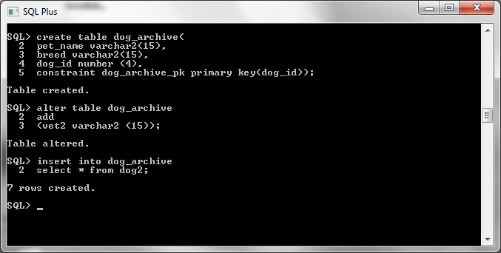

Update:
Update dog_archive da
Set vet2=’Kirby’
Where dog_id in
(select dog_id from dog2
Where dog_id =1);
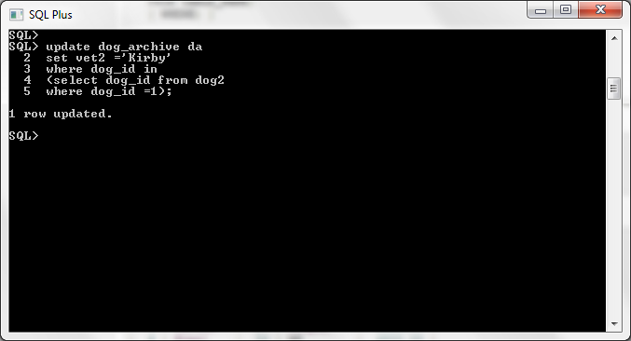
Delete:
Delete from dog_archive
Where dog_id IN
(select dog_id from dog2
Where dog_id >6);
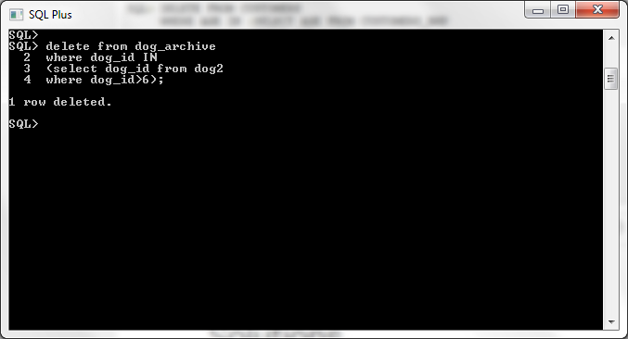

Merge with sub queries:
We created dog2 table here:

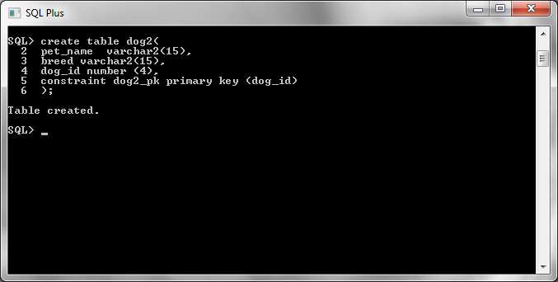
Merge:
merge into dog2
using dog d
on(d2.dog_id=d.dog_id)
when matched then
update set
d2.pet_name=d.pet_name,
d2.breed =d.breed
when not matched then insert
(d2.pet_name,d2.breed)
values(d.pet_name,d.breed);
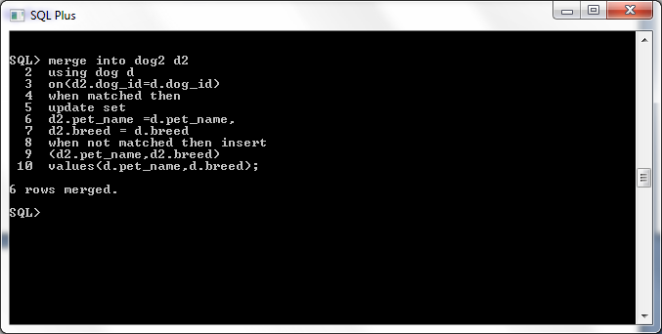

- Update rows and watch locks:
Lock table dog2
In exclusive mode;
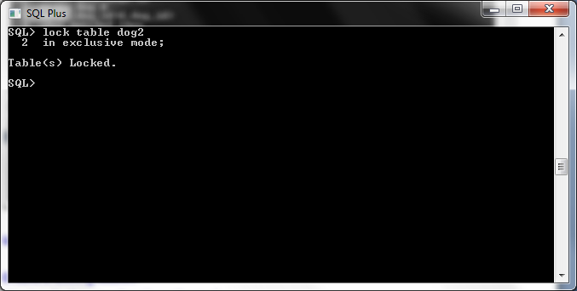

We logged on as sys dba and set a lock. We also, logged in as user john and watched to see what happens. We learned as each user executed the commit statement, the lock was released and the sql statement was able to execute for the other user. When sys locked, john was left “hanging” indefinitely until the commit was issue by sys user.

User : sys
Lock table dog
In exclusive mode;
Commit;
Lock table dog
In exclusive mode
Wait 30;
Commit;
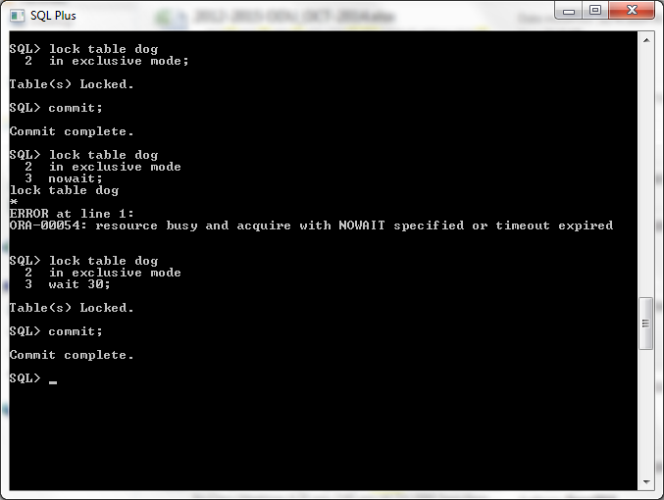

User: john
Delete from dog where pet_name =’Brownie’;
Commit;
Delete from dog where pet_name =’Cosmo’;
Commit;
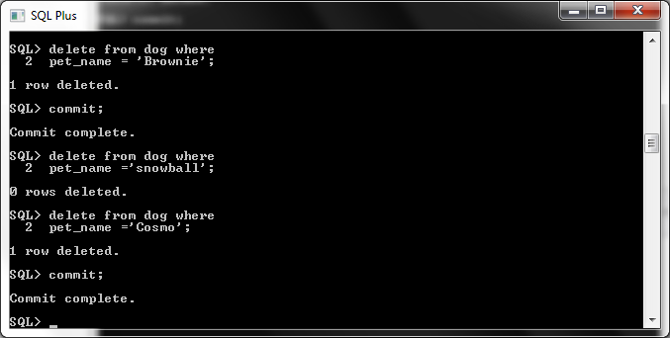

- Create a locking session
Created a lock on dog with user: sys.
Lock table dog
In exclusive mode;
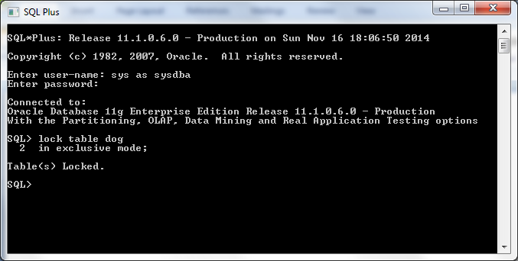

Logged in as user: John , verified lock exists.
Insert into dog
(pet_name,breed, dog_id)
Values
(‘Cosmo’, ‘pug’,8);
Notice the curser is “hanging”, meaning john as a user is waiting for the lock to be commited by sys user.

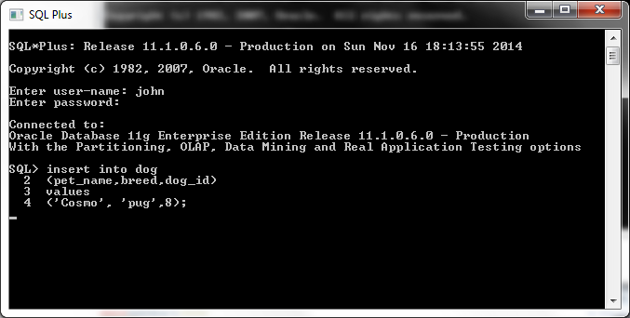
Logged in as sys dba on enterprise manager. ( last row= exclusive lock)
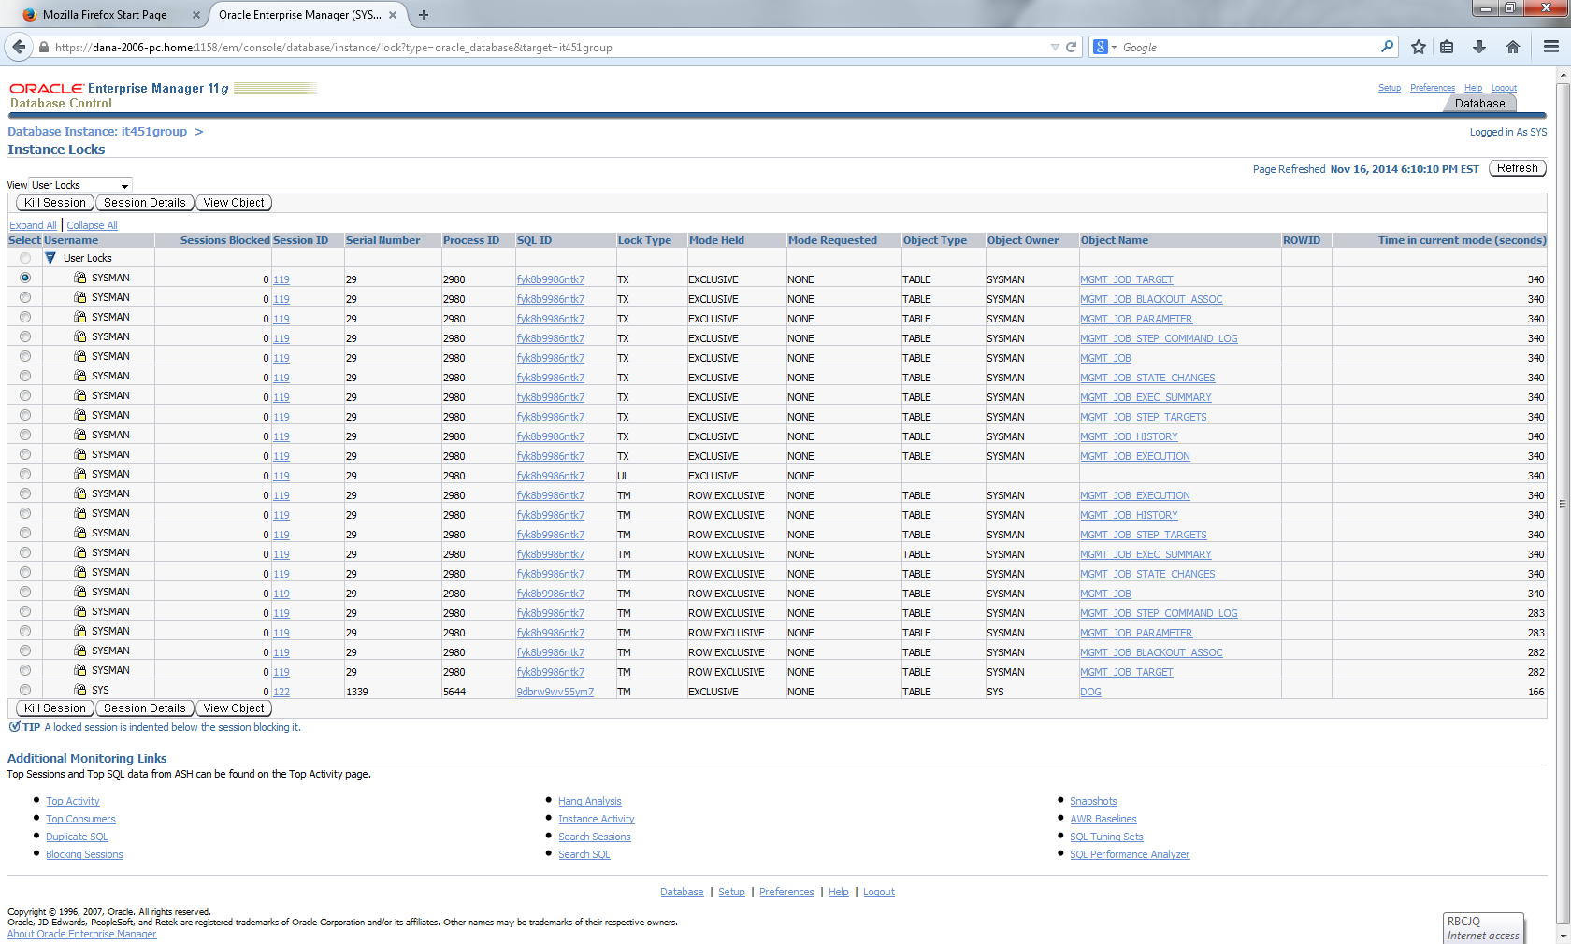

Session details on sys lock on dog table.
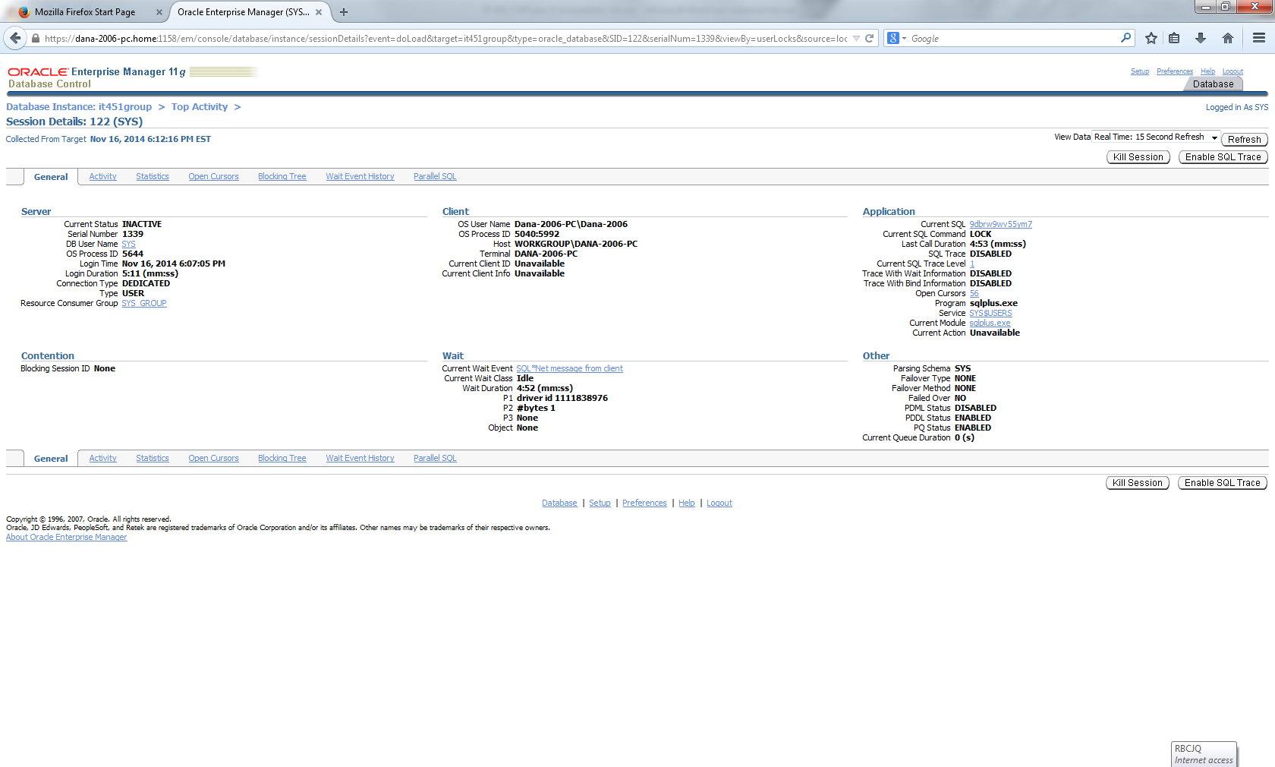
- Monitor locks using Database Control
Notice the lock on user john, for table dog.
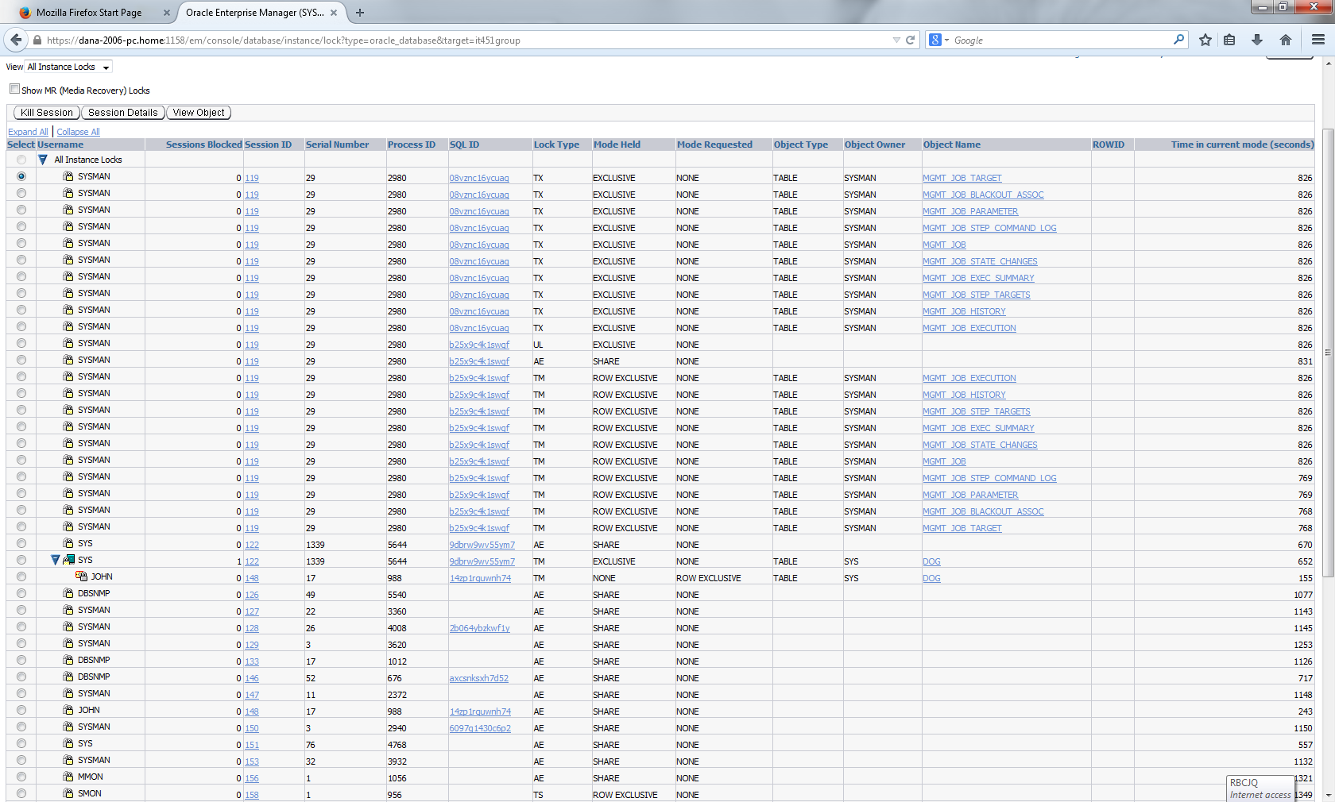

- Watch instance activity, blocking locks screens on Database Control
Blocking lock screenshot:
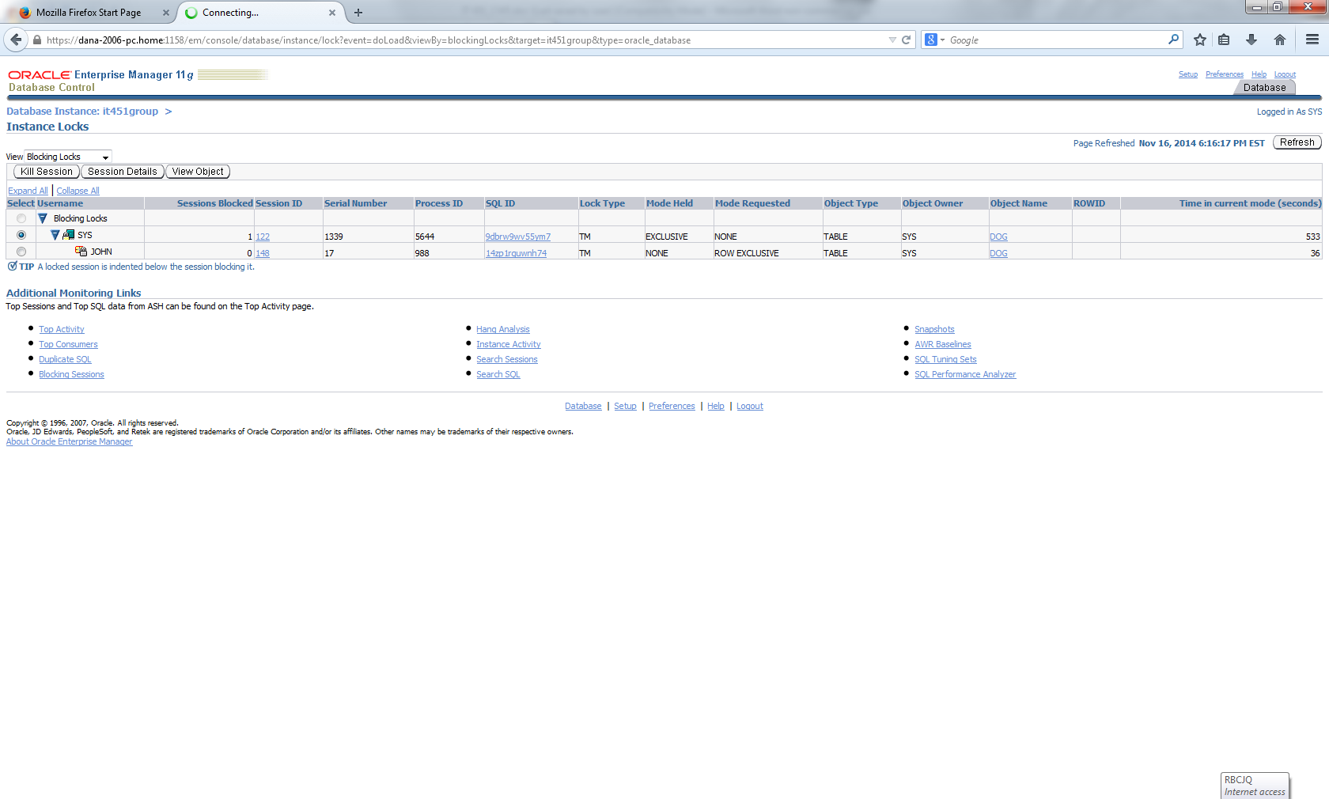
Instance activity screen shot:
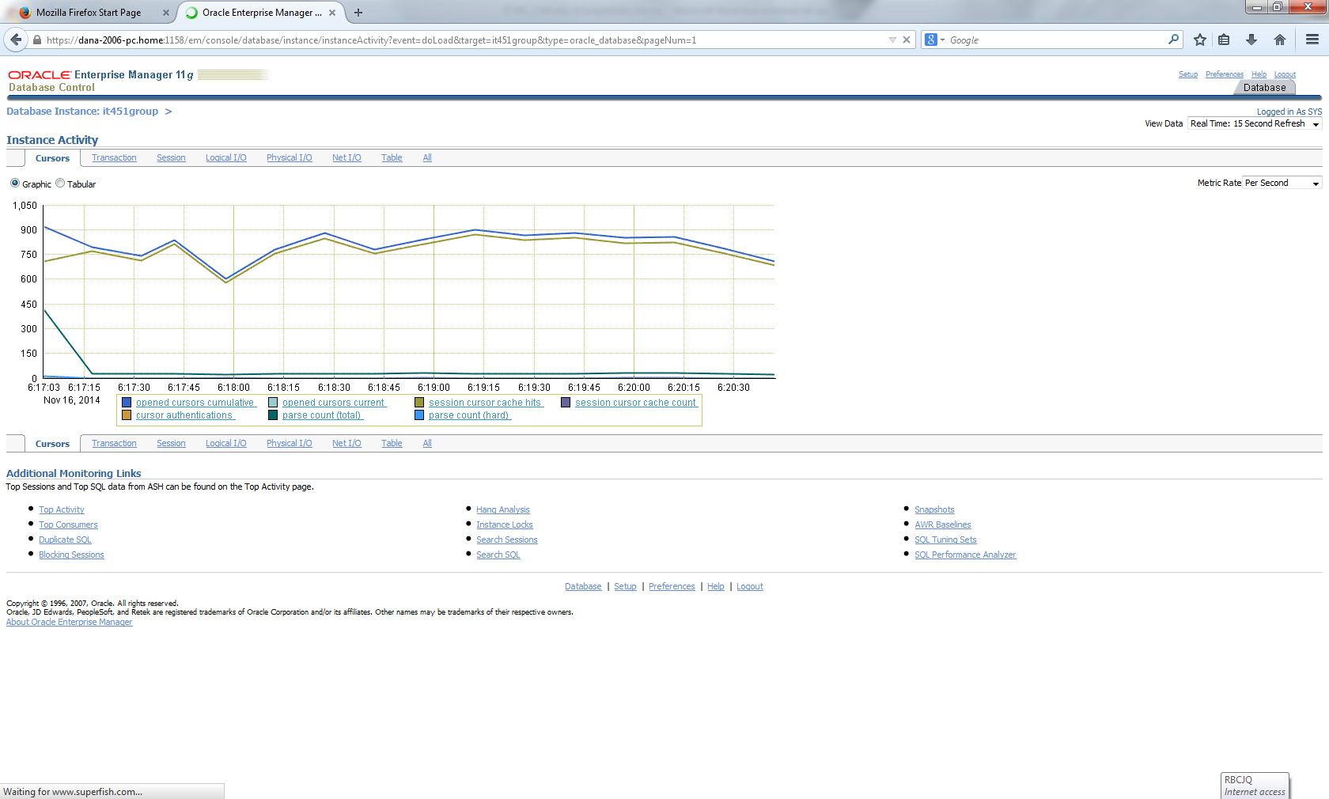

- Use Database Control to monitor undo and undo
The automatic undo management screenshots:

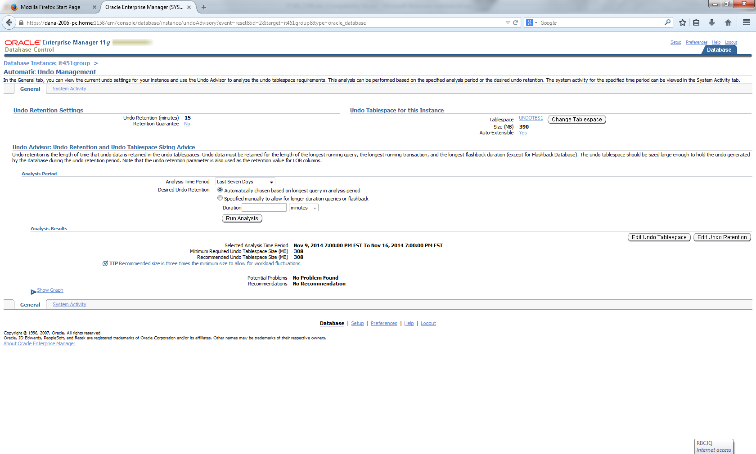
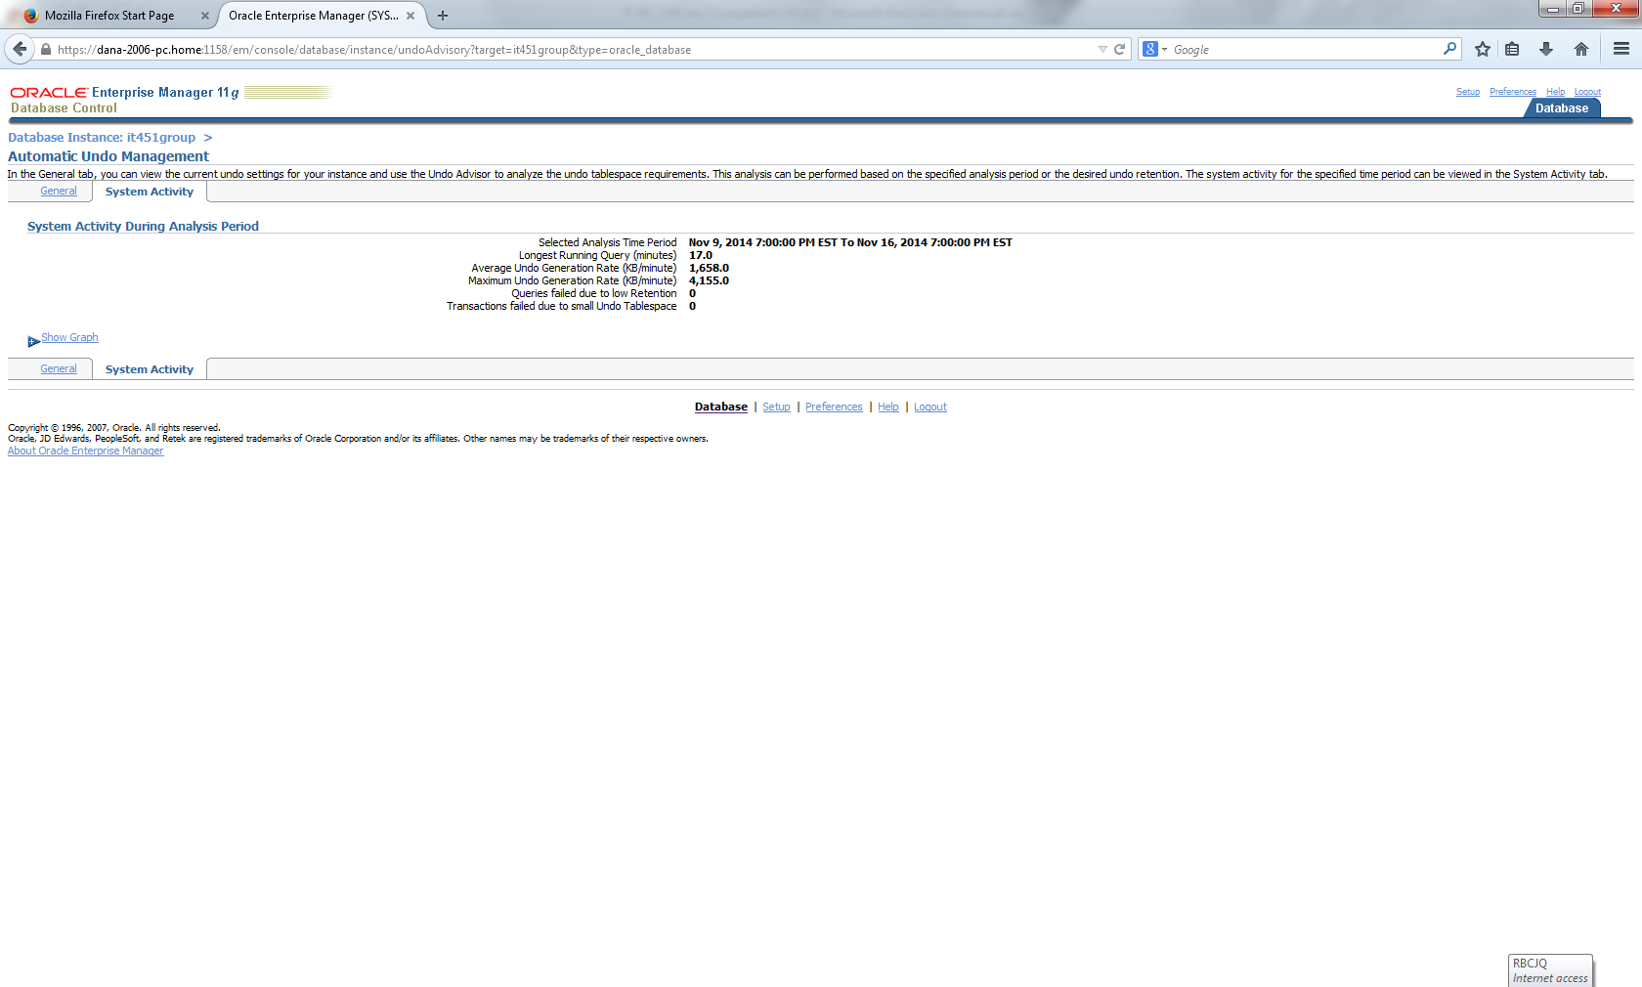

Automatic undo management screen with graphs:
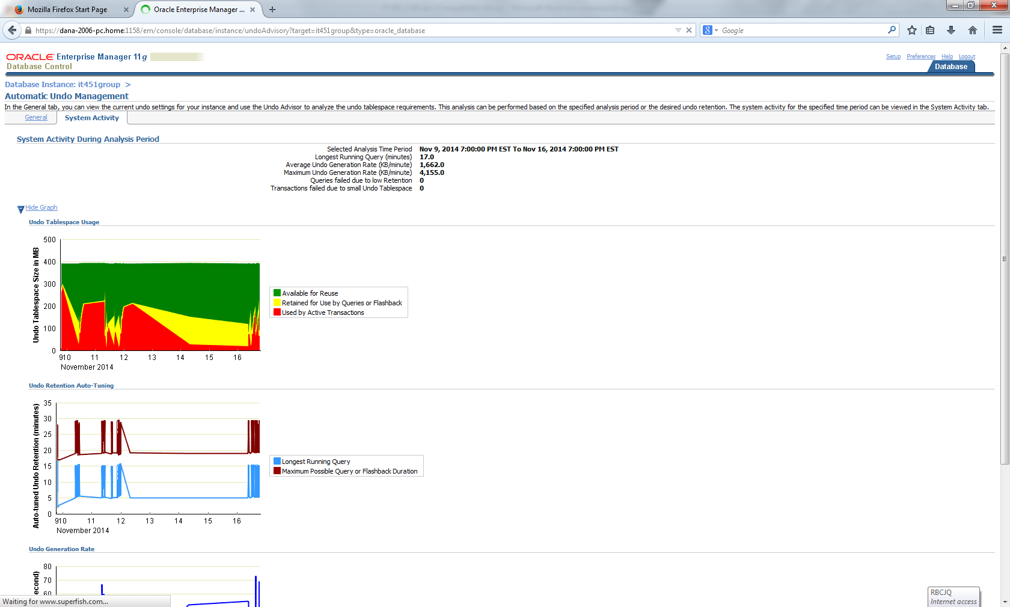

We logged in as john
Deleted one row from dog.
Then did a rollback and the row was recovered. Meaning the row was saved in the undo log, and was retrieved correctly.

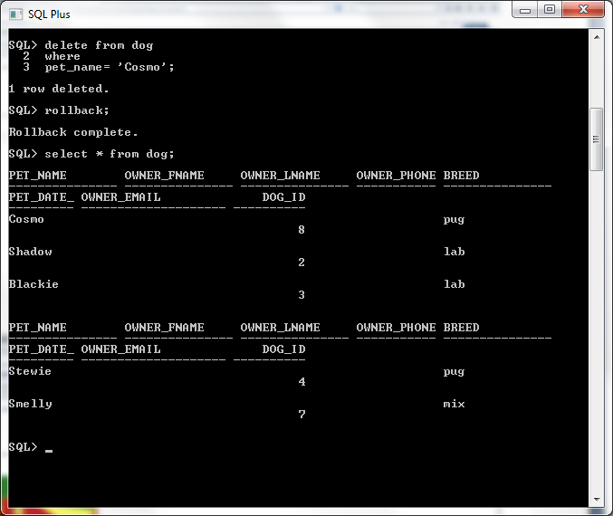

Screen shot of undo table:
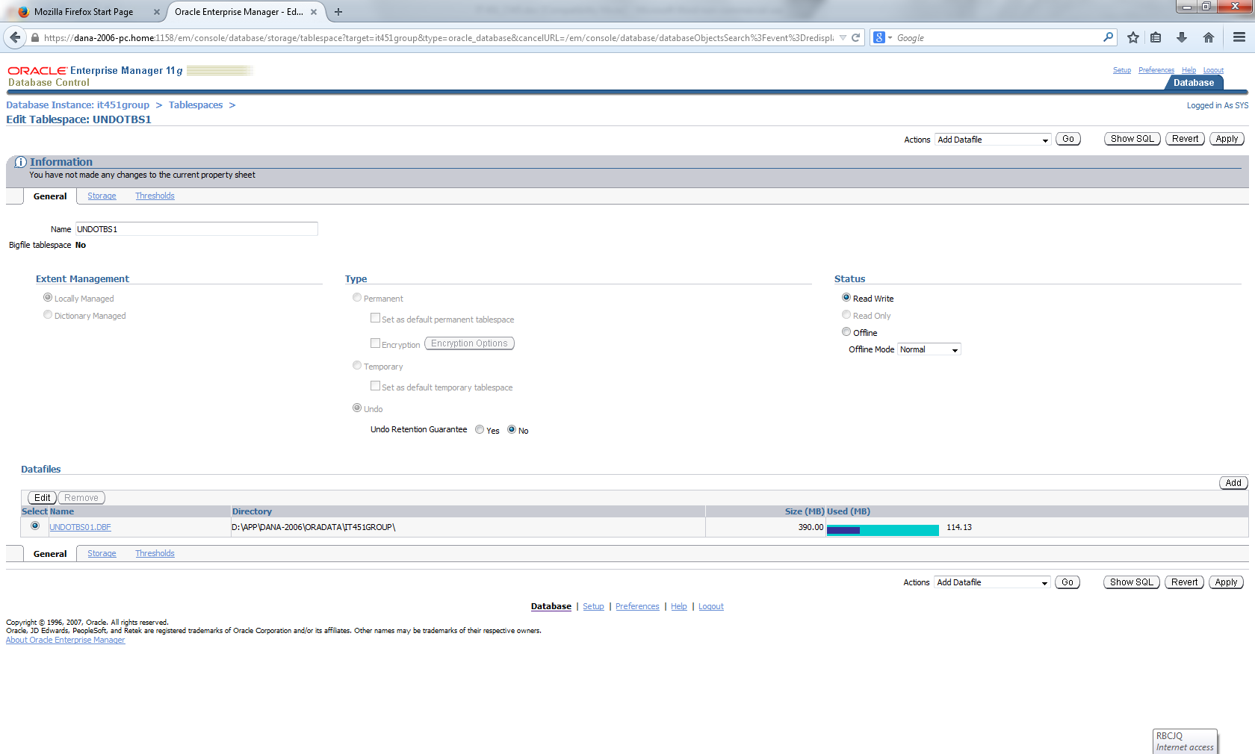
Screenshot of edit undo table:
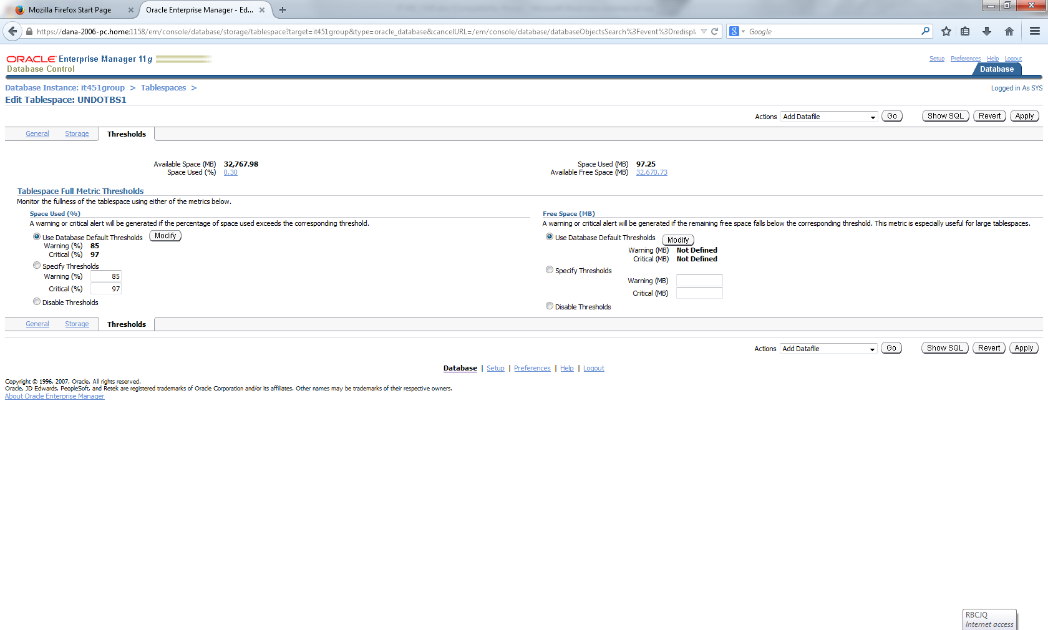

Screenshot of undo table:
